Maths at Alsager Highfields Community Primary School
Mathematics is an essential part of a balanced curriculum that is both well matched and challenging to the learner’s needs. As a creative and highly inter-connected discipline, it is essential to everyday life, critical to science, technology, and engineering, and necessary in most forms of employment.
Maths Mastery Definition
When taught to master maths, children develop their mathematical fluency without turning to rote learning and can solve non-routine maths problems without having to memorise procedures. Evidence shows that children need to be able to understand a concept, apply it in a range of situations and then be creative to really understand it.

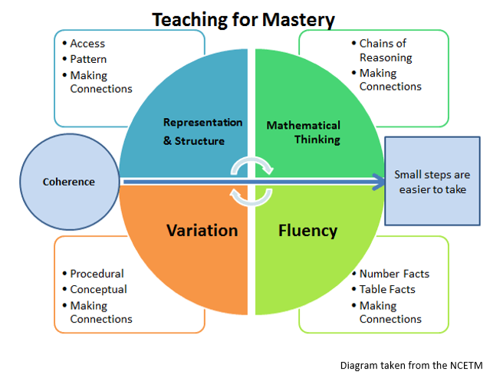

Our Intent
At Alsager Highfields Community Primary School we provide a nurturing environment where every child can believe in themselves and achieve, living our motto ‘Nurture, believe and achieve.’
We have adopted a Mastery Curriculum approach to our teaching of mathematics. This means spending greater time going into depth in areas or concepts rather than quickly moving through the curriculum and the year group objectives.
In having high expectations that all children will achieve, all children are given the opportunity to explore, find and identify patterns, become fluent, reason and problem solve and are exposed to carefully crafted questions and activities with a wide range of manipulatives at hand for all to accomplish this.
Differentiation by task or setting has not traditionally led to better outcomes for lower attaining pupils. Cohorts of children are taught in mixed ability classes, where scaffolding, timely intervention and teachers and other adults working directly with those who are struggling to grasp a concept provide more effective differentiation.
We strive to ensure that the whole class moves through content at the same pace and when we differentiate, it is through depth rather than acceleration; everyone is given time to think deeply about the maths and we strive to develop a positive attitude to build self-confidence, resilience, and a sense of achievement. Questions structured with a “greater depth” of complexity are used allowing children to explore and investigate the mathematical concept; develop their ability to reason, prove or question an approach. Children may support each other as collaborative learning allows them to support each other’s progress. Children understand that ‘deeper reasoning’ challenges provide them with opportunities to apply their learning with additional challenge.
Our intention is for every child to develop a sound understanding of Maths through a progressive acquisition of knowledge and skills. This helps our children to know and remember more through both well timed repetition and carefully planned tasks to introduce new learning.
How is our curriculum designed and implemented?
The way we structure our lessons ensures a consistent approach to teaching maths; a greater emphasis on the sequence of learning; better use of open-ended investigational type questions and the continued development of mathematical pedagogy.
The mastery approach we use ensures that there is high expectations for all children; little chance for passive learning as there is a greater emphasis on talk in maths, collaborating, exploring, and investigating; use of equipment which is actively encouraged and planned opportunities for children to make connections between subjects.
We are in the process of implementing the Maths No Problem Foundation which provides a programme of teaching and learning activities, exercises, and stories which deliver a firm foundation for developing maths mastery in Key Stage 1. Within each unit, there are a selection of activities which include talking time, thinking time and possible journal activities in a workbook; games which support the learning concept; suggested stories and assessment opportunities. Picture books also inspire children to the wonderful world of maths which is what the Foundations Programme advocates. Through exploring and talking about the images in the books, children build on their understanding of basic concepts and begin to look for patterns, connections, and relationships. The engaging images provoke discussions that are tailored for different stages of development. Supplementary activities are suggested for children to creatively explore both inside and outside the classroom.
Each story is designed to inspire learning experiences that involve the use of concrete objects to facilitate the development of basic skills as well as higher-order thinking, depending on the children’s readiness.
Following the EYFS framework 2021 and the ELG for Maths including knowledge of number and numerical patterns, maths lessons emphasise talking about maths, collaborating, exploring, and investigating. Maths activities are practical, fun, and engaging, and are centred around children's interests. The use of open ended, investigational type questions focuses on the continual development of mathematical pedagogy. Their learning is active and the encourages the children to develop their own ideas, make links between ideas and develops strategies.

Maths No Problem
To further develop our maths mastery curriculum, we continue to use Maths No Problem throughout our school. It is a new scheme that follows the Singapore approach to teaching mastery maths. It helps pupils develop a deep, long-term, and adaptable understanding of maths. There are some new concepts and methods that are very different to what we used before; however, the scheme provides detailed guidance and clearly outlines each block which is broken down into smaller steps, which are cyclical which in turn ensures progression. For each small step there is guidance on teaching points, key questions to raise which encourage mathematical thinking, talking, and reasoning. This sequential learning enables children to make sense of their previous learning. Small steps for both conceptual and procedural understanding are planned for, giving due consideration to common misconceptions that are likely to occur. Additional quality materials such as those provided by the NCETM, or Gareth Metcalf are also used.
Lesson Structure
Each lesson follows this structure:
- Explore: presenting the whole class with a problem to explore – an anchor task. Children can work in groups or pairs exploring the task which can include concrete resources, use, and draw on previous knowledge, drawing, modelling, using different strategies
- Sharing of ideas and approaches used to solve or attempt to solve the problem - activating prior knowledge, exploring how children have approached the task, look at each method, then encourage the children to note down other methods used. Teachers can observe and assess.
- Journal their initial ideas.
- Master: a structured discussion of their exploration. Teacher led, using targeted questions, different methods are drawn out, discussed, along with any misconceptions. What are you doing in this strategy and why are you doing it?
- Read and reflect : This can be at any point in the lesson; however the children are given opportunity to read through the textbook. The Master section is presented as though it was someone’s journal which allows the children to compare, discuss and reflect on methods.
- Guided Practice: The teacher can be modelling solving a given problem step-by-step or children can be working together in pairs to solve the questions, using the methods discussed.
- Independent Practice: Children answer workbook questions independently.
- Greater Depth Task/Journalling: this involves children taking a question and extending their ideas –Prove it; Investigate Patterns or Pose a problem.
- Prove it – show in diagrams, symbols, pictures, write down examples which work and those which do not. Is there more than one solution?
- Patterns – develop their own investigation – eg. Is this always, sometimes, or never true? Do they notice any patterns? Can they find any? Have they thought of all the possibilities? How can they be sure?
- Pose a problems- can children create a solve a similar problem?
- Feedback: the plenary may focus on addressing a misconception, self, or peer review.

Teachers use questions to challenge thinking throughout every lesson to check understanding. Children are also encouraged to question each other frequently throughout the lesson; this aids the development of independent learners and deepens their understanding. Children are expected to listen to each other’s responses and may be asked to explain someone else’s ideas in their own words, or if they agree/disagree etc.
Discussion and feedback – pupils have opportunities to talk to their partners and explain/clarify their thinking throughout the lesson but are expected to complete written work independently (unless working in a guided group with the teacher). The plenary may focus on a addressing a misconception, self or peer review, or further assessment depending on where the lesson sits in the cycle of teaching and learning.
There will be times when this lesson structure does not suit the learning taking place. When longer investigations, games or kinaesthetic activities are taking place, the structure will be that which best suits the learning process.
Children use concrete, pictorial, and abstract models for each topic as appropriate to the learning context. Research conducted by the EEF underpins our expectation that both manipulatives and representations will be used in all year groups and across all ability groups to support learning before procedural methods are used. This will allow children to select from a range of strategies for both efficiency and to support success.
- Concrete – using concrete objects and manipulatives to help them understand what they are doing.
- Pictorial – use pictorial representations to help reason and solve problems.
- Abstract – both concrete and pictorial representations are pre-requisites to support children’s understanding of the abstract methods, reasoning and problem-solving.

Fluency in the National Curriculum
One of the three aims of the new curriculum states that pupils (of all ages, not just primary children) will: become fluent in the fundamentals of mathematics, including through varied and frequent practice with increasingly complex problems over time, so that pupils develop conceptual understanding and the ability to recall and apply knowledge rapidly and accurately.
In our teaching of maths, we know that fluency in computation is important. National initiatives emphasise this – for example the arithmetic tests which children sit as part of SAT’s in Y6 and through the MTC, multiplication tables check in Y4. To aid this we have allocated a separate 15 minutes, timetabled during the day, to allow fluency to be taught outside of our daily maths lesson.
Children who are identified as having specific areas to address may receive additional intervention.
What is the impact of our curriculum?
The measure of our impact is woven in with each unit or block that is taught. Teachers clearly model the processes; children have opportunity to practice the skills or process and receive instant feedback throughout the lesson with live marking. The work is pitched to provide for stretch and challenge where appropriate with reasoning questions which ask children to apply and deepen their learning and understanding.
Marking is timely and allows children both to complete, correct and go deeper with their learning. Children who make no mistakes are not being sufficiently challenged and we expect all children to respond to any marking which is not simply for correction, but for recall, reflection, and self-monitoring.
There is opportunity to use unit reviews or mid-term reviews and end of term assessments where every year group makes use of prior SAT’s papers, NFER tests, all of which are standardised. These provide an overview of attainment, progress and an analysis of strengths and areas for development, both of a cohort, a class and of individuals. All of which feeds back into the teaching and learning.

September 2022

