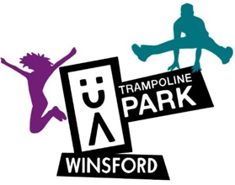

We are very pleased to offer rebound therapy at UA Trampoline Park. These are mainly 1:1 sessions, ideal for those with additional needs. Rebound Therapy is the phrase used to describe the specific model of trampoline therapy known as exercise therapy to provide opportunities for movement and therapeutic exercise.

The main benefits include the developing and improvement of:

- Strength of limbs
- Numeracy
- Patience
- Communication
- Co-ordination
- Independence
- Self-confidence
- Balance
- Muscle tone
- Reaction speed
- Self-image
- Eye contact
- Relaxation
- Freedom of movement
- Sense of achievement
- Stamina
- Spatial awareness
- Body awareness
- Social awareness
- Consideration of others
- Trust and confidence in Coach or Assistant
- Colour recognition
- Height and depth perception

And most importantly - FUN and ENJOYMENT
Other benefits include:
- Stimulation of digestive system
- Improved bowel function, Internal organ massage

How We Aim to Achieve These Benefits:
We use the internationally recognised Winstrada development and award scheme which records and rewards progress.

For those with profound and complex needs, we use the Huddersfield Functional Index in conjunction with the Winstrada scheme.

Contact: Kirsty - info@uacheshire.co.uk
Location: UA Cheshire Trampoline Park – Unit 9 Winsford Industrial Estate, CW7 3RL
Telephone: 01606 212690
Rebound Days: Term Time Only.
Mondays 14:30-18:30 Wednesday 13:00-18:30 Thursdays 13:15-16:00 and 17:30-18:30
