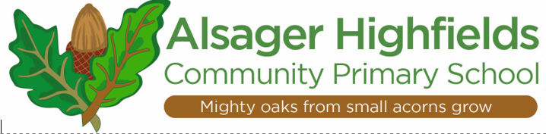

Music at Alsager Highfields Community Primary School
Music is an essential part of a balanced curriculum. As a creative and highly inter-connected discipline, it is essential to everyday life. At Alsager Highfields we recognise the importance The Arts play in creating happy pupils with self-belief and a healthy mental wellbeing. We therefore ensure all pupils have access to a wide range of experiences.
Our Intent
The National Curriculum for music aims to ensure that all children:
• perform, listen to, review, and evaluate music
• be taught to sing, create, and compose music
• understand and explore how music is created, produced, and communicated.
At Alsager Highfields Primary School the intention is inspire creativity, self-expression and encourage our children on their musical journeys as well as giving them opportunities to connect with others. We hope to foster a lifelong love of music by exposing them to diverse musical experiences and igniting a passion for music. By listening and responding to different musical styles, traditions, and genres, by finding their voices as singers and performers and as composers, all can become confident, reflective musicians.
Our objective at Alsager Highfields is to develop a curiosity for the subject, as well as an understanding and acceptance for the importance of all types of music, and an unbiased respect for the role that music may wish to be expressed in any person’s life. We are committed to ensuring children understand the value and importance of music in the wider community, and can use their musical skills, knowledge, and experiences to involve themselves in music, in a variety of different contexts.
How is our curriculum designed and implemented?
Our music curriculum is supported by Charanga, which enables teachers to follow and make use of effective planning, providing for musical progression through and across the curriculum, giving sufficient and regular time for development of children’s ability to sing, listen to, play, perform and evaluate a range of music. This is embedded in regular classroom activities and music making for all, complemented by weekly singing assemblies, concerts and/or performances, additional tuition with opportunity to gain experience of learning an instrument, outside partnerships and extra-curricular activities. The elements of music are taught in the classroom lessons so that children can use some of the language of music to analyse it, and understand how it is made, played, and appreciated. In the classroom children learn how to play an instrument and in doing so they understand the principle of creating notes, as well as how to read basic music notation. They also learn how to compose focussing on different dimensions of music, which in turn feeds their understanding when listening, playing, or analysing music. Composing or performing using body percussion and vocal sounds is also part of the curriculum, which develops the understanding of musical elements without the added complexity of an instrument.
Alongside Charanga, our music curriculum is designed and enhanced by the involvement of Love Music Trust. Through this involvement, different phases have expert tuition and projects with which they become involved. In the EYFS, the children take part in the Betty Bear project produced by ‘Love Music Trust’ in the Summer Term which incorporates many musical elements. Year 1 and 2 also take part in the ‘Barney Bear Project’, again produced by ‘Love Music Trust’. This culminates in an external production that parents can come and watch. A LKS2 class is taught to play an instrument, either the ukulele or recorder. Y5 also learn a brass instrument during the Summer Term – organised through Love Music Trust and learn how to play the African Drums. Y6 children also have had the opportunity to take part in a musical production, produced by Alsager School, participating alongside High School students, during the Spring Term and also have the opportunity to take part in musical workshops organised by the High School as part of our transition process.

What is the impact of our curriculum?
Whilst in school, children have access to a varied programme, which allows them to discover areas of strength, as well as areas they might like to improve upon. The integral nature of music and the learner creates an enormously rich palette from which a child may access fundamental abilities such as: achievement, self-confidence, interaction with and awareness of others, and self-reflection. Music will also develop an understanding of culture and history, both in relation to students individually, as well as ethnicities from across the world. Children can enjoy music, in as many ways as they choose- either as listener, creator or performer. They can analyse music and comprehend its parts. They can sing and feel a pulse. They understand how to further develop skills less known to them, should they ever develop an interest in their lives.

Curriculum Recovery
The school recognises that there might be gaps in children’s knowledge and skills because of the period of school closures during the pandemic in the summer of 2020 and spring 2021. Further to this, the music curriculum has changed, and this too poses challenges with the depth and breadth of the children’s knowledge and skills. To address this, we have identified areas where the children may have limited knowledge, skills, and experiences and, as a result, have explored and adapted to both the existing and new model music curriculum using Charanga as a spine for teaching music.

October 2022

