Mental Health Week – Nature
How can nature benefit my mental health?
Spending time in green space or bringing nature into your everyday life can benefit both your mental and physical wellbeing. For example, doing things like growing food or flowers, exercising outdoors or being around animals can have lots of positive effects. It can:
- improve your mood
- reduce feelings of stress or anger
- help you take time out and feel more relaxed
- improve your physical health
- improve your confidence and self-esteem
- help you be more active
- help you make new connections
- provide peer support
See a grid of nature activities below.

Walking: Going outside for a 15-minute walk is probably the easiest form of exercise. Talk a walk around the school field. | Water painting: Get a pot of water and a brush and pint your worries on the playground. Watch them melt away. Or simply create a work of art.  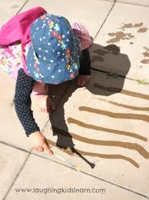 | Bubble relaxation: Get a bubble pot or mix washing liquid with water. Gently blow the bubbles and watch them drift off into nature.  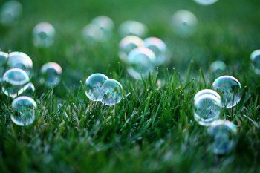
Gardening: Plant some sunflowers. These cheerful flowers track the sun each day.  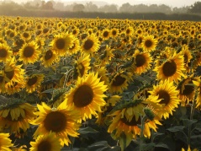 | Bring nature indoors: Have some class plants to nurture and water each day. Plants give out oxygen and this adds oxygen to your room.  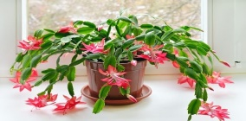 | Andy Goldsworthy art: Get creative with natural materials and make a picture.  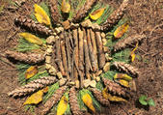
Talking Tokens: Spark a debate. Everyone collects a handheld natural object. Start a debate/open ended question. You can only speak when you add your token to the circle. | Bug hotel: Build a shelter for the insects using natural materials.  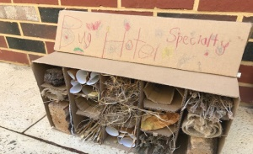 | Pebble Power: Make a tower of pebbles ( a cairn) How many pebbles can you balance before it collapses? Which are the best pebbles to use?  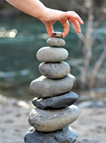

Nature dream catcher: Make a dream catcher from natural materials to trap those unwanted thoughts.  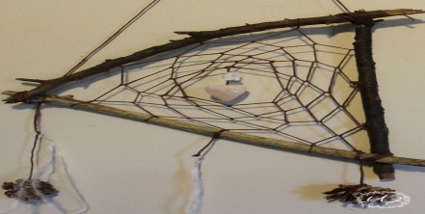 | Cloud Watching: Lie down and watch the clouds drift by or see if you can make images from the clouds. | Sense of touch: Feel the soft, green new leaves on trees around you. Take note of how they feel.  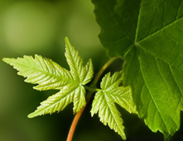
Listen: Can you notice different birdcalls coming from the trees and hedges around you?  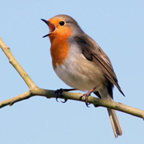 | Who’s been framed?: Gather some loose materials and create a portrait of someone you know. Can anyone guess who it is?  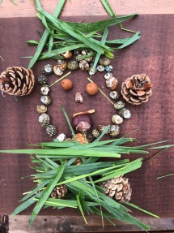 | Get to know a tree: One of you is blindfolded, while the other guides. Setting off from a shared starting point, the guide takes their blindfolded partner on a winding walk before choosing a tree. The blindfolded person then sets about getting to know that tree in all ways but sight. When ready, the guide leads their partner back to the starting point (again, a winding route is good to add to the challenge). Then the blindfold is removed and that person has to find their tree.
Mud painting: Get creative with some mud and a pot of water to create a masterpiece. Experiment with different consistencies.  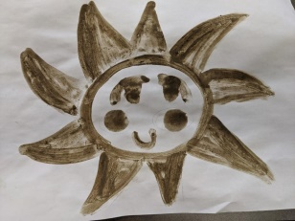 | Tree boggarts: Boggarts are mischievous creatures who live in forests. They help to protect our woodlands. Create your own boggart using clay and natural materials.  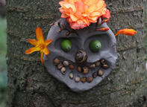 | Bark rubbings: Get paper and crayons to take a rubbing. Compare the patterns and textures on different trees.  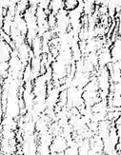

Bird feeders: Make a bird feeder to attract more birds to our field and hedges.  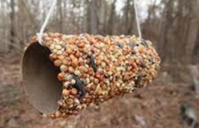 | Different weather: Go out in two different weathers. Compare sights, sounds and smells.  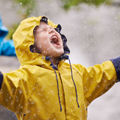 | Make a daisy chain: Join up with your classmates to make the longest daisy chain possible.  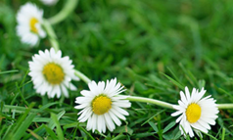
Fairy/Gnome/Elf Garden: Can you use the materials around us to build a fantasy world?  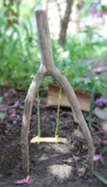 | Robin Hood: Create a bow using sticks and string.  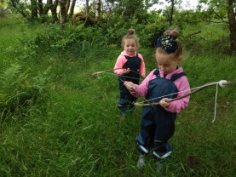 | Japanese Art of Hapa-zome: It means leaf dye. Pound plants and leaves to release their dye onto a cloth.  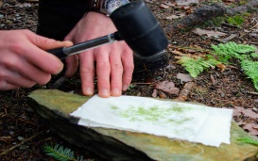
Fill bottles with water and make a bowling game. Give each pin a number and add them together to see who can get the highest score. Multiply numbers for a harder challenge.  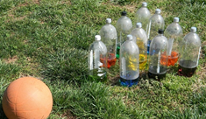 | Scarecrow Festival: Using natural materials, create a class or group scarecrow.  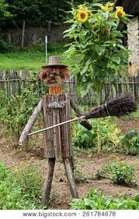 | Story Stick: Tell a story using natural materials attached to a stick. (Double sided tape needed.)  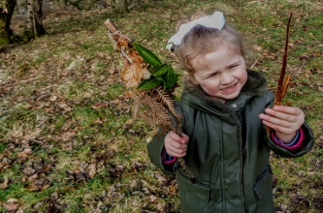

Picnic Time: Have a class picnic outside.  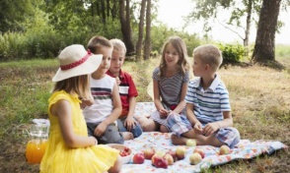 | Garland: Using 1m of string, thread leaves together to make a garland.  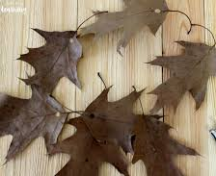 | String Things: Using 1m of string, make a Cat’s Cradle. How many different patterns can you make on your hands?  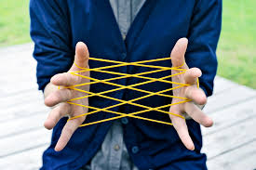
Dance in the rain and splash in the puddles. You will soon dry. | Seed bombs: Take a selection of wildflower seeds and mix them into a ball of earth. Take them home to place in an area to encourage bees.  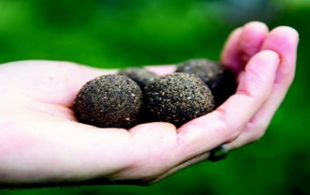 | Make repeating patterns using pebbles, leaves, twigs etc.  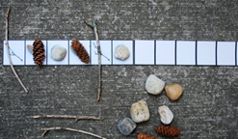
Living Books: Recreate your favourite book scene using natural materials.  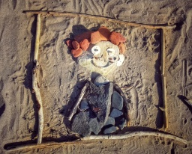 | Match box challenge: How many different (non-living) items from the field can you fit in your box? How did you decide what to include?  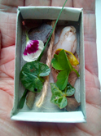 | Ground yourself: Slip off your socks and shoes to feel the grass beneath your feet and toes.  